COGNIZANT

WEEK 2 : MODULE 5:SPRING CORE AND MAVEN

EXERCISE 1:CONFIG A BASIC SPRING APPLICATION

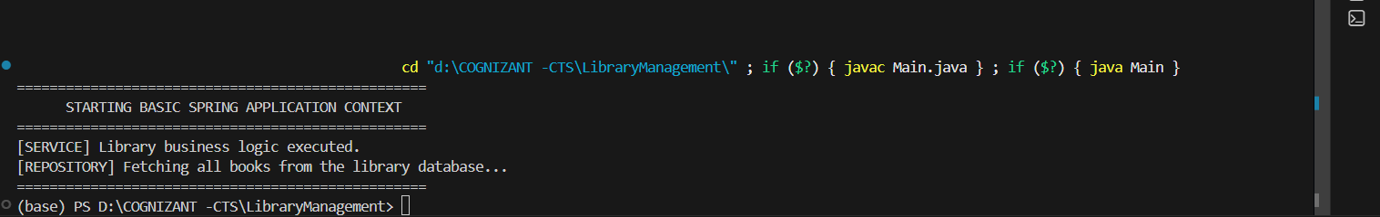

EXERCISE 2 :IMPLEMENTING DEPENDENCY INJECTION

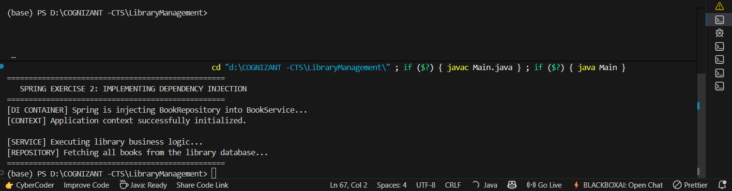

EXERCISE 4:CREATING AND CONGIG MAVEN

